Use of the digital textbook in the educational process
Doctorand: Doroftei Ecaterina
Coordonator: Conf. dr.Balmuş Nicolae
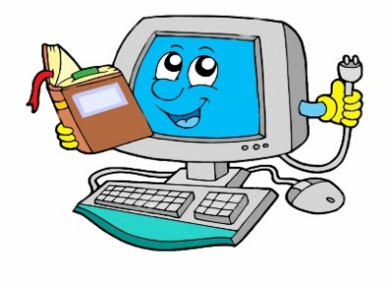

Why?
This is the first question any teacher, any student and any parent who hears talking about a digital textbook asks.
I think the solution to a good start and a successful implementation is to present all the benefits of using this digital manual. If we leave it to everyone to look for their own advantages or disadvantages, I don't think we will be able to change anything.
In general, people are quite reticent about change. They may not find it easy to give up a printed textbook because, until now, they have only read such books.
Then there are many who say they need technology for such a manual. This is the truth: to work in a classroom we need a laptop / computer and a video projector. If they were working at home, students would need a laptop / computer. In 2014, the introduction of digital textbooks in schools was attempted in Romania. Thus, each printed manual was accompanied by a CD containing the digital manual. Although it seemed like an interesting idea to us, I have not met any teacher who would use it permanently and no student would use it at home.
Perhaps a presentation was needed first, for teachers , students and parents alike, about its functionality and the many benefits of using it.
This is why I set out to list some great advantages of using a digital manual in the process of teaching-consolidation-evaluation.
First of all, I would like to point out that a digital textbook is not just the content of a printed textbook. There is a big difference between them. The digital manual contains much more information and applications.
If you open such a manual you will find that it looks exactly like the one initially printed, but if you start browsing it you will find that most of its pages will appear on the side of the page with more types of additional applica- tions. Thus, some buttons appear that will be pressed to provide us with one of the following elements: a video to help the lesson on that page, a rebus, a grid test, some conclusive photos, an interactive test, a link that sends you to an internet page which also helps the lesson, various types of diversified exercises . Even a final test with everything that will help you check yourself if you have correctly assimilated the concepts in the new lesson.

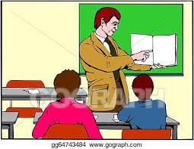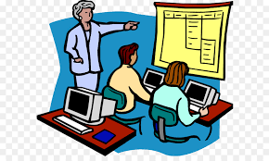
Here's how many there are and I haven’t listed them all. Here's how much extra material can be added to a lesson, compared to the classic lesson in a printed manual. I think this is the biggest advantage of a digital manual: it contains much more information and helpful materials. How long would it take a teacher, parent, or even a student to look for such helpful materials himself in each lesson? Very much. Here's what a big win. Nowadays, when everyone complains about lack of time, here's a solution to having everything you need for a lesson without wasting time searching for yourself. And within the class time itself: in the 50 minutes allocated, many more applications can be made if we use this type of manual. We will no longer need to work with all kinds of additional files, which also involve costs . Using the digital textbook students can look at the materials presented on the video projector in front of the class. Whenever you can work on a test, application or exercise, you also gain a lot of time.
All this applies to any educational discipline. We'll talk about the mathematical object now. For example, in the teaching process: when new concepts, new formulas have to be introduced, it is much easier for a student if they are presented with more information about that concept. The teacher can use all kinds of photos, articles, legends, videos from the digital manual for a better understanding. Then, throughout the class, the newly learned formulas can remain displayed on the wall in front of the class and the students work on the applications using them.
Then comes the consolidation part. Students have the opportunity to do several types of exercises at the same time. And meanwhile they can be checked.
In a digital manual, a given exercise can change its data or numbers each time the exercise is terminated. Thus, instead of a single exercise that can be written in the classic manual, here we can find a colossal number of exercises and applications. Depending on the work pace of each student, he or she can work more or less exercises. A great advantage here would be the classes in which each student could have a computer.
As for the evaluation part, here is a big advantage here too. On the one hand, the teacher is advantageous because he can generate as many test variants as he needs with an application belonging to the digested manual. Or you can call for online testing that offers the result at the end.
On yhe other hand, the students have to win at this point. They can prepare at home for a future test by working on various types of tests that can be found in the manual.
We conclude clearly that the quantity of information,the number of elements, tests and exercises in a digital manual is much higher than in a classic printed manual.
And all these advantages are paling compared to the strongest argument off al: the youngsters are attracted by technology. Giving them a way to improve their knowledge by using electronic equipment and technology is a powerful, meaningful, futuristic and friendly approach wich they will resonate with for sure.
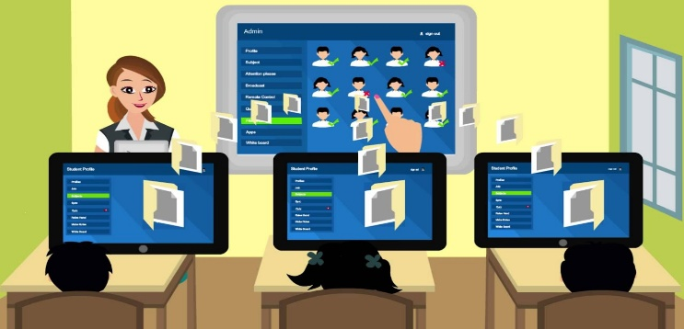
I will let you draw your own conclusions on the benefits of using the digital manual, and we will discuss it further.
I believe this is the future of education.

