Puppets in speech therapy
Liceul Teoretic ,,Ana Ipătescu” Gherla,
Cluj, România,
Prof. logoped Buta Corina Nicoleta

The Moowi Puppets are speech and language therapy tools with which mouth and tongue articulation exercises will never be boring again. This is a great help for speech-language pathologists, kindergarten educators, teachers and therapists as well as for parents, that is for all those who care about children’s speech development.
Puppets are excellent speech therapy tools for use in working with children. I find at least five reasons:
1) it is easier to establish contact with a child,
2) you can show how to properly arrange the speech organs,
3) children are more likely to mimic the puppet,
4) it encourages the child to act spontaneously and thereby,
5) speech therapy exercises turn into fun. They make the hard speech therapy work fun – interesting, colourful and effective.
1) It’s easier to establish contact with a child
A child’s first contact with a speech therapist may be difficult. The child may feel constrained by the presence of an unknown adult. It also may be difficult for him/her to understand what he/she is expected to do. For this reason it is a good idea to present a puppet as a speech therapy assistant at the beginning of the class and thus to reduce the child’s anxiety. With the help of a friendly and sympathetic puppet, in a relaxed atmosphere, you can explain to the child how the therapy will look like. As a result, it will be easier to establish a trusting relationship and encourage further therapy.
2) You can show how to properly arrange the speech organs
The hand puppet with a mouth and a tongue is ideally suited to demonstrate articulation exercises to the child, as well as to show how he/she should arrange her/his speech organs to pronounce a given sound. At the next stage, you can swap roles. The child may explain how to practice to the puppet. In this way the child – by engaging in the entertaining exercises – acquires the necessary knowledge which translates into better results in speech therapy.
3) Children are more likely to mimic the puppet
The child will identify himself/herself much more easily with a puppet, which is plush, colourful and cheerful, than with an adult. All the puppet does is pique the child’s interest. Therefore the puppet helps not only in the exercise of articulation and triggering sounds, but also at the stage of their fixation in syllables, words and sentences. Additionally, it effectively encourages the child to follow and repeat exercises.
4) The puppet encourages the child to act spontaneously
No other speech therapy tools encourage a child to act spontaneously and thus promote the development of vocabulary and improvement of his/her talking capabilities as effectively as puppets. When “speaking through the puppet” the child may feel more comfortable and at ease. Supporting such spontaneous activity is particularly important in working with children with delayed speech development and in speech disfluencies therapy.
5) Speech therapy exercises turn into fun
The involvement of the child in speech therapy exercises is the key to effective therapy. The hand puppet as a cheerful, colourful and sympathetic speech therapist assistant will help you achieve this effect. Let’s not limit your imagination!

- EXERCICES
  - Articulation exercises for kids – tongue gymnastics with Dino

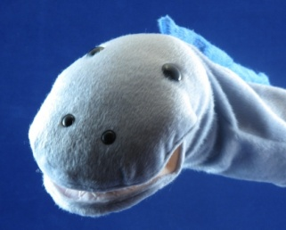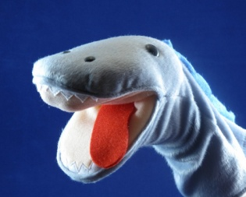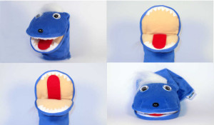
Articulation exercises are extremely important in the prevention of speech disorders as well as speech and language therapy of children. How to encourage children to perform them? We present a scenario of articulation exercises for kids that will be led by the Dino hand puppet. They can be done both in kindergarten and at home.
Articulation exercises with a puppet can be used during individual lessons, group classes, as well as to diagnose articulation organs efficiency.
SCENARIO:
“Our little Dino is a very friendly, cheerful dinosaur and often smiles. It has a big mouth (we open our mouth widely) and a long tongue (we stick the tongue out). Dino’s tongue is very agile (we stick the tongue out and then hide it, as far as possible). It also has strong teeth – let’s count how many there are (we touch all the teeth one by one, at the bottom and at the top, with the tip of the tongue).
Dino is a big glutton, as soon as it thinks of something tasty it licks its jaws around (we lick the lips around) and it munches loudly (we imitate munching). It loves to eat candy (we imitate sucking of a candy). When a piece of a candy gets stuck in its mouth, behind its teeth, Dino detaches it with its tongue (we touch the upper teeth with the tongue).
Dino carefully brushes its teeth after eating (we move the tongue along the lower and upper teeth), it checks whether all are clean (we touch the tip of the tongue to the top and bottom teeth). When all the teeth are sparkling clean, Dino grins (we grin), and even sends kisses (we arrange the mouth like the spout). Dino is very fond of games and its favourite is the imitation game.
We perform any of the above articulation exercises for kids, the speech therapist / teacher performs an exercise, presents it using the puppet and then the child repeats. Then we switch roles – the child teaches the puppet.”
2.2.Thech speach with finger puppets- in articulation and phonology
I use these finger puppets in speach therapy, particularly for my speech kids.
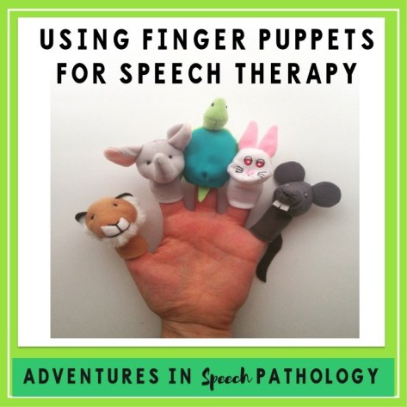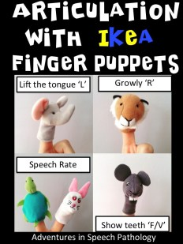
TIGER = R SOUND
I love to talk about using a ‘growly’ sound for making ‘r’ and this tiger puppet is fantastic! Sometimes I hide him and he will come out and make funny growl at the kids when they use their ‘r’ sound. So simple. So motivating.
ELEPHANT = L SOUND
I love the trunk on this elephant and so when I am teaching the ‘l’ sound I ask my kids to lift their tongue up like the elephant. It’s a really great visual and has worked wonders for me!
TURTLE + RABBIT = SPEECH RATE
We all have had those kids that speak sooooo fast that their speech sounds just go everywhere. These two puppets are fantastic for working on slowing down speech for increased clarity as most kids know the tortoise and the hare analogy. I have also taught the opposite with some of my CAS kids, children who ‘overthink’ what to do, and students who break up sounds in their speech (c-ar).
RAT = F & V SOUND
Usually I would pull out my rabbit to work on these and have found some kids benefit from the term ‘show me your rabbit teeth’, but this finger puppet rat has two lovely chompers that I have had to change my phrase when I use these. Like the elephant with the ‘l’ sound, this is a great visual reference.

2.3. Puppets Can Help Develop Language and Communication
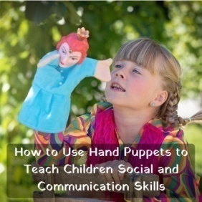
I used the puppet theater every year in "Other week", I took the puppet props and the decoration in grades 0-4 with which we have concluded cooperation agreements. The activities were very successful and loved by the children. They stimulated their imagination, interest in conversation, attention to correct oral expression.
For many children, it opens up a new world of communication that supports the acquisition of language skills. One very effective way to develop children’s language skills with puppets is to role-play to model oral language. This might mean modeling correct sentence structure or introducing new vocabulary into the conversation. Children learn to converse and formulate their thoughts and words to best convey their message.
Puppets are engaging toys that can help support oral language skills and communication, social/emotional development, and help children learn and understand the world around them through safe, imaginative play.
The children made masks, created dolls for fingers or puppets caught on a stick of scruff or straw.
In the puppet workshop, the children worked in small groups, inventing between themselves the story lines and the characters, and negotiating who should make what. I asked them to draw a simple storyboard or write out their story in two or three sentences, and to make a list of characters, backgrounds and props. They were limited to no more than four characters and four background scenes per story, and asked to keep spoken words to a minimum and commit them to memory, to ensure that performances were short and spontaneous. (Some children found this aspect very challenging, wanting to write scripts and read from them, so I had to explain that it was impossible to read and perform with puppets at the same time. Some groups solved the problem by using a narrator (who was allowed a script) and
keeping the puppets virtually wordless.)
Conclusions:
As speech and occupational therapists, we can use puppets to help teach the rules of conversation, general social interaction and causal connections.
Putting puppets into the hands of children—or rather on the hands of children—can set the stage for valuable learning opportunities in many developmental areas. Puppets are engaging toys that can help support oral language skills and communication, social/emotional development, and help children learn and understand the world around them through safe, imaginative play.
Hand puppets, finger puppets, and marionettes all spark the interest of children. Puppet theatres are important because they provide a safe place behind the curtain—and most children find them less intimidating for performing plays. Puppets offer children an engaging way to interact and explore their knowledge and understanding of the world. For instance, when a child is able to talk through a puppet, suddenly sharing isn’t so scary.
Parents can incorporate puppet play at home too/ Many are surprised to find their child is more willing to engage when they aren’t forced to interact directly, but the lessons still carry over to real life. Sometimes assigning certain roles to certain puppets (i.e., “good guy,” “bad guy,” etc.) can be helpful in terms of consistency in conflict resolution.
Finger puppets or stick puppets can work well (and helping your child make one can be a fun craft!), though larger hand puppets are especially effective attention-grabbers.
References:
- Kroflin, Livija - ,, The Power of the Puppet”, The UNIMA Puppets in Education, Development and Therapy Commission Croatian Centre of UNIMA, Zagreb, 2012
- The American Journal of Occupational Therapy - ,,The Use of Drama and Puppetry in Occupational Therapy During the 1920s and 1930s”, March 1996.

